

VILNIUS UNIVERSITY
SIAULIAI ACADEMY
BACHELOR PROGRAMME SOFTWARE ENGINEERING

SYSTEM APPLICATIONS AND PRODUCTS IN DATA PROCESSING (SAP)

E-service Design Principles and Infrastructure Solutions. Practical Work № 8

Student :
Lecturer: Prof. Dr. Dale Dzemydiene

Siauliai, 2023

SD 1: Display Customer Master Data
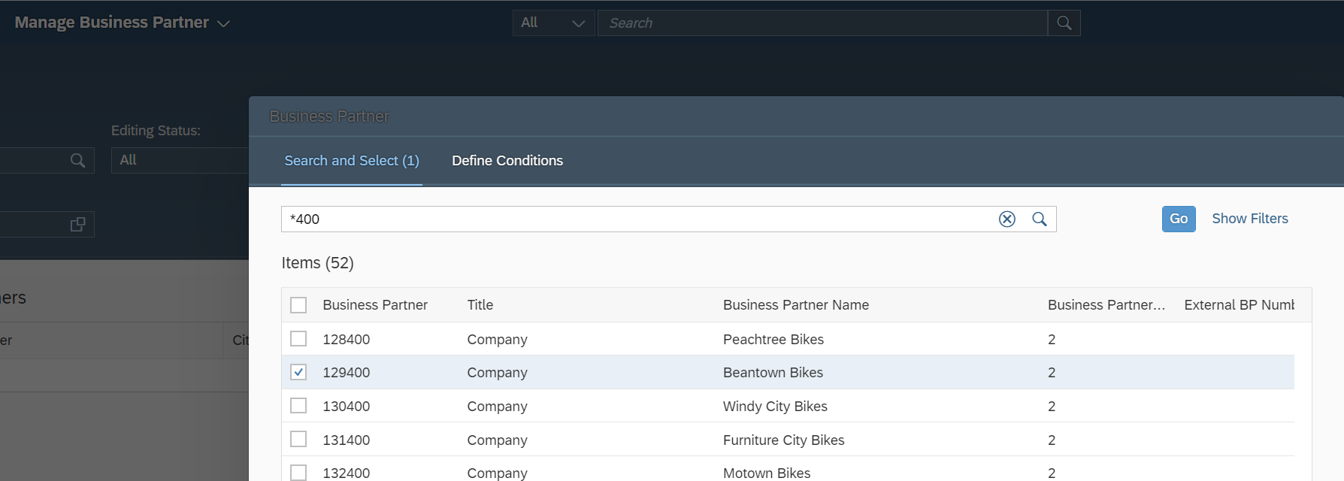
Task Global Bike has several customers in the USA. Display one customer from the USA (Beantown Bikes).

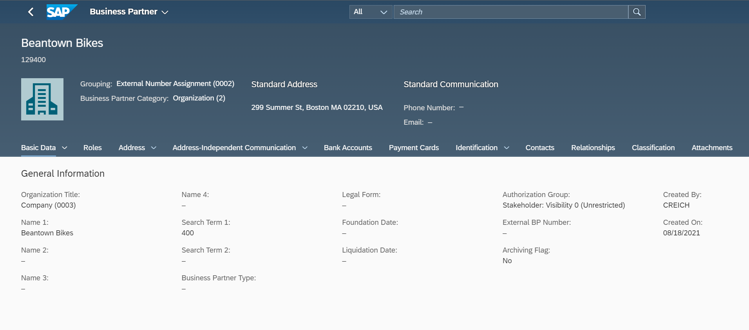
Pic 1. In the list of all business partners we choose Beantown Bikes partner

Pic 2. This screen displays the general data of your customer Beantown Bike
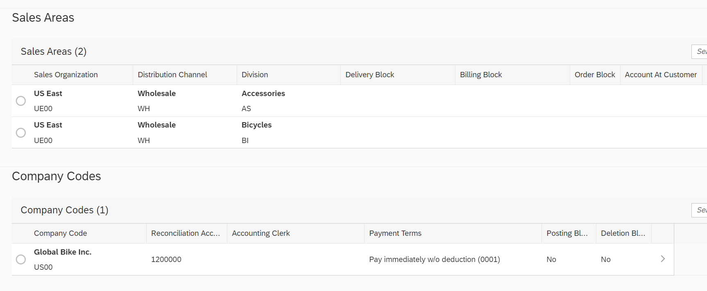

Pic 3. Sales areas of the Customer (FLCU01), which we chose in business partners roles.

SD 2: Display Customer Order
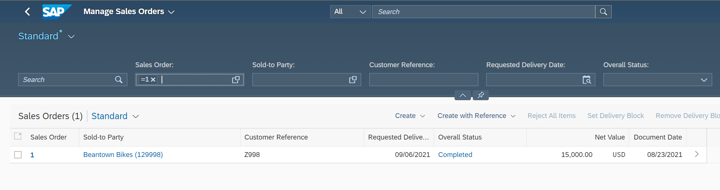
Task: Display a customer order for black Deluxe Touring Bikes.

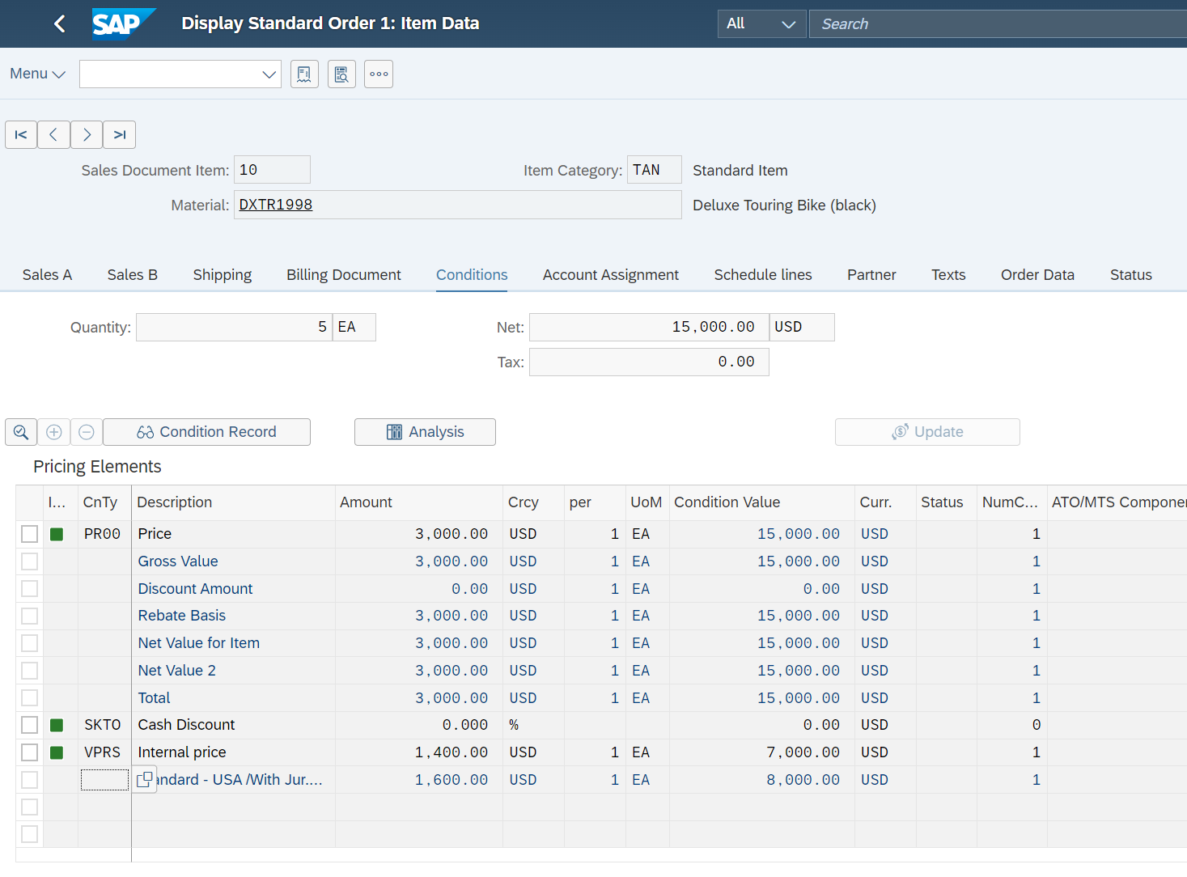
Pic 4. List of created sales orders with corresponding orders

Pic 5. Item condition in All Item Overview. There we can see that each bicycle costs 3,000.00 USD and that neither discounts nor supplements were determined. It furthermore shows that Global Bikes makes a profit of 1,600.00 USD per bicycle sold.
SD 3: Display Outbound Delivery Document for Sales Order
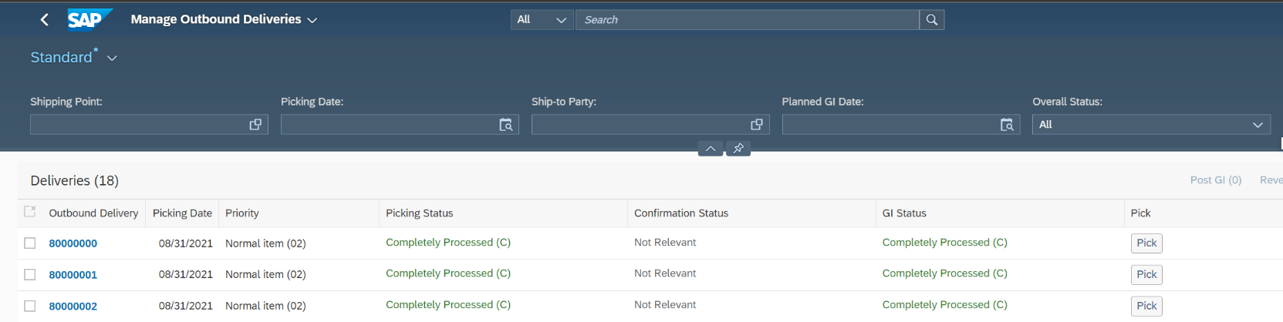
Task: In the context of the sales order process, after creating the order, the outbound delivery takes place. As a next step, please display the outbound delivery document.

Pic 6. The outbound delivery document for a sales order.
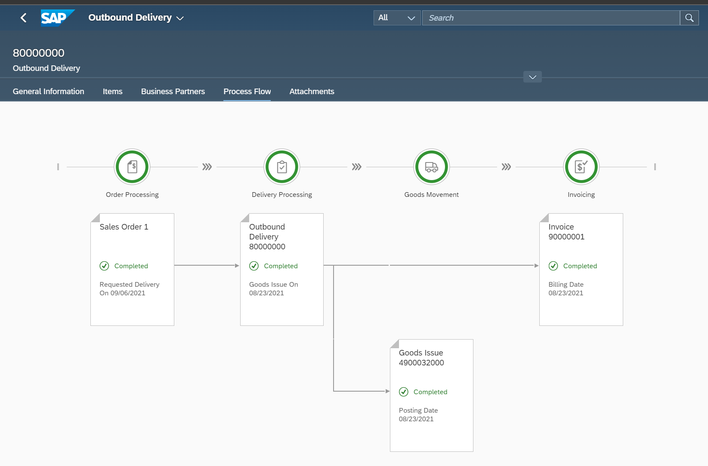

Pic 7. all relevant documents, including the sales order of the previous step.

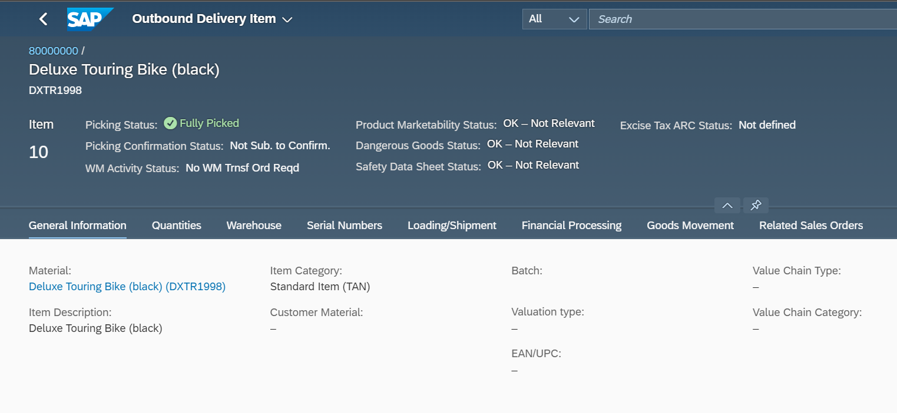
Pic 8. Detailed view of the item.

SD 4: Display Billing Document
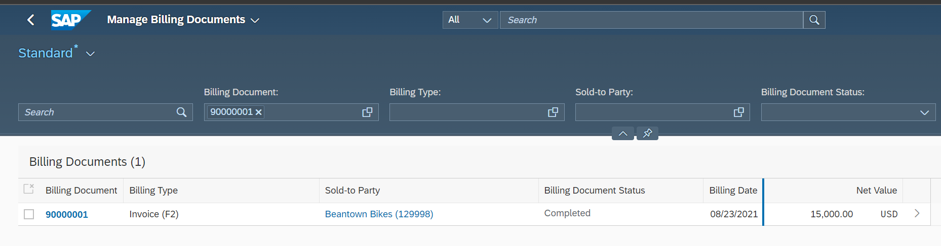
Task: After the delivery of the bicycles to the customer, an invoice was created for the customer. Display the billing document in the system.

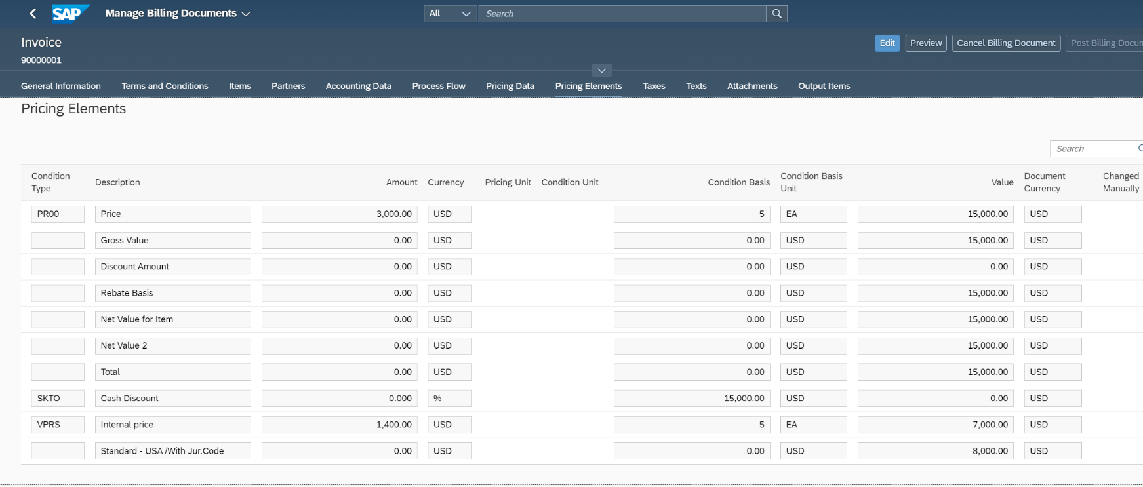
Pic 9. The billing document for the corresponding sales order

Pic 10. Pricing Elements tab on the detailed view of the billing document. There is a list of all the items that are going into the net value, including the internal price of 1,400.00 USD per bike, which represents costs for Global Bike.

SD 5: Analyze Document Flow
Task: There are various possibilities to display the Document Flow. It is possible to open it directly from sales order document.

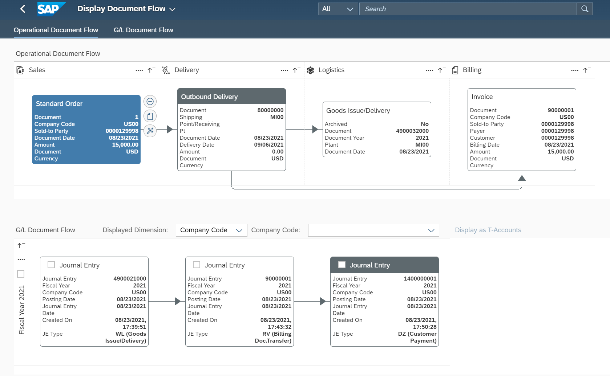

Pic 11. Two document flows are displayed: One is the Operational Document Flow and the other is the G/L Document Flow

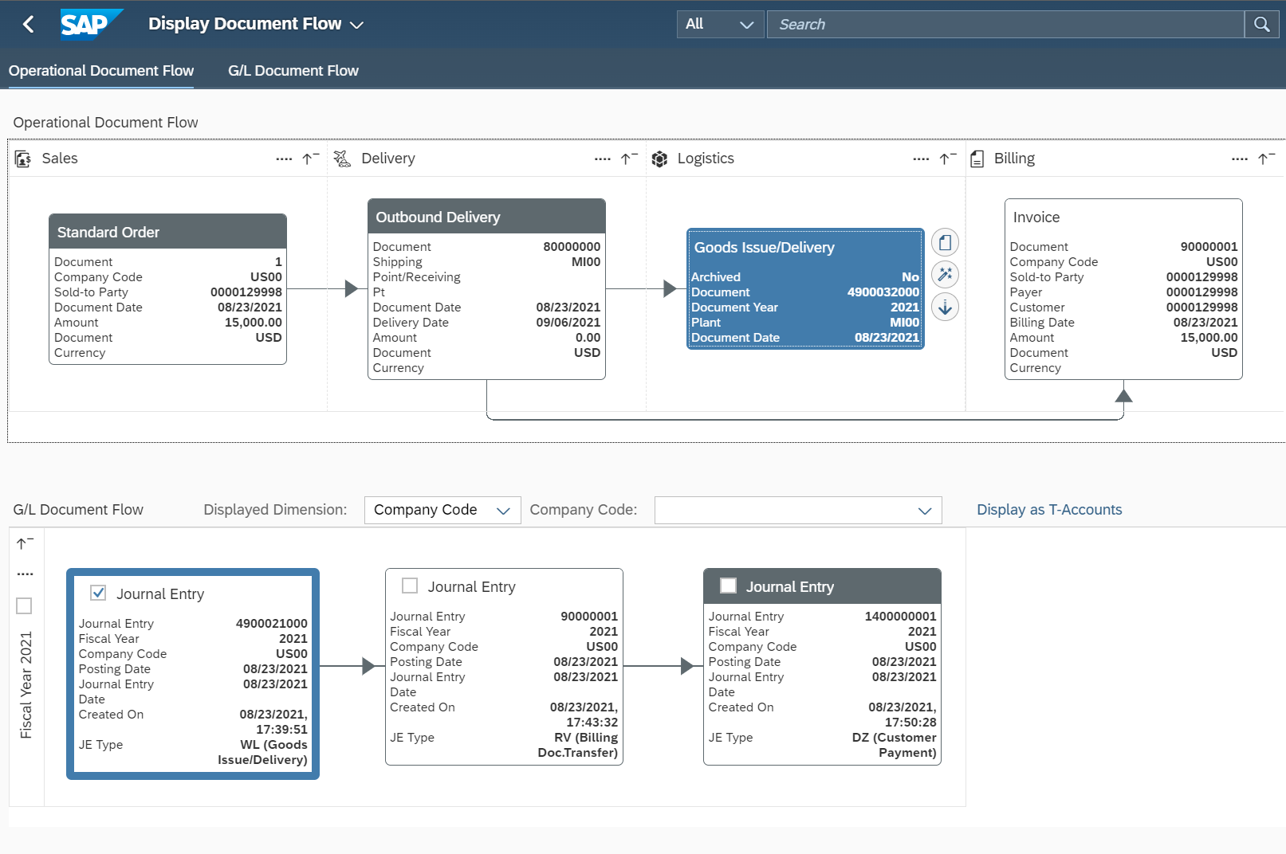
Pic 12. Select Goods Issue Document From Logistics
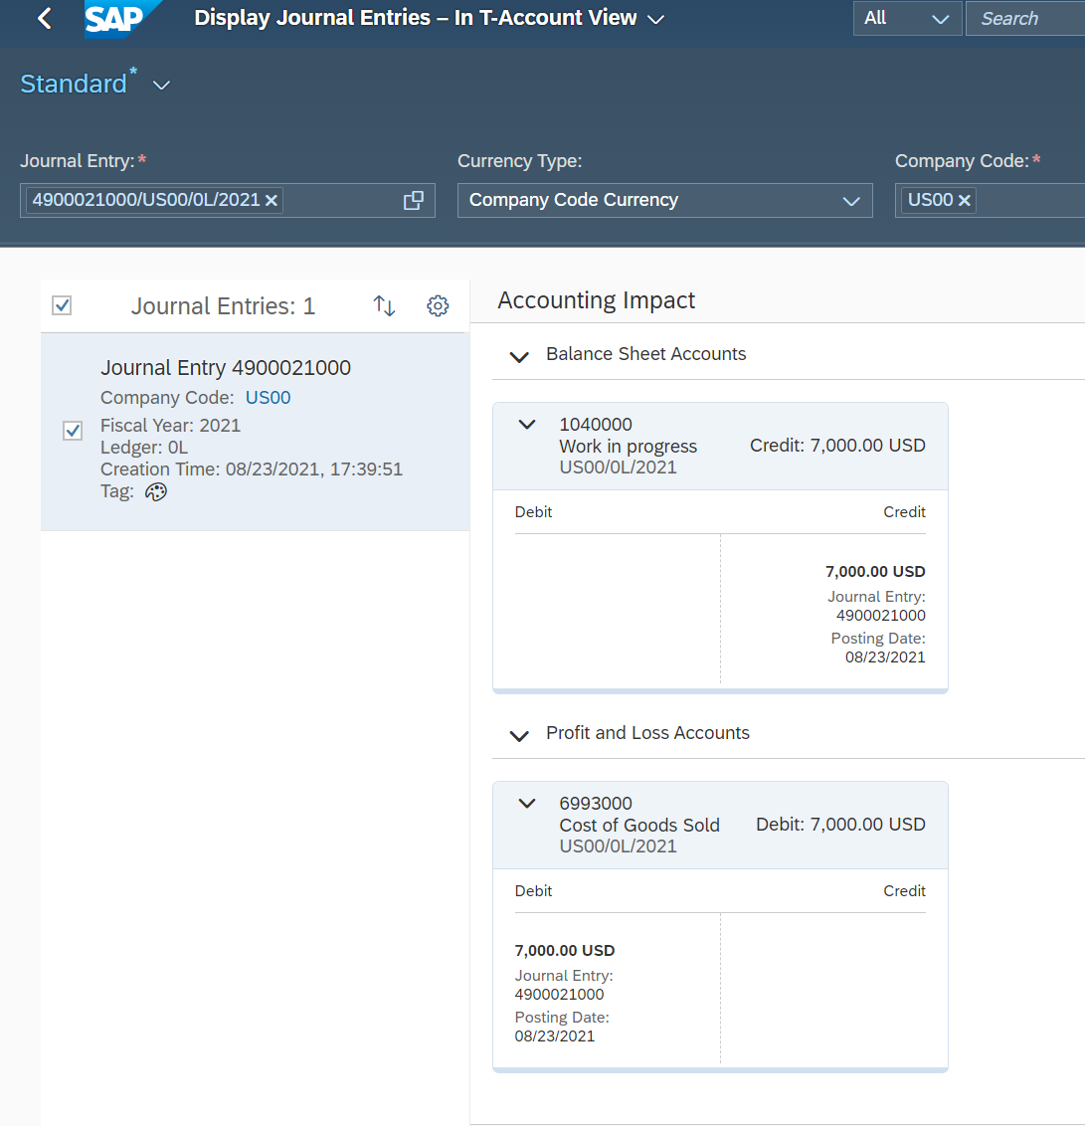
Pic 13. Display Journal Entries –In T-Account View screen
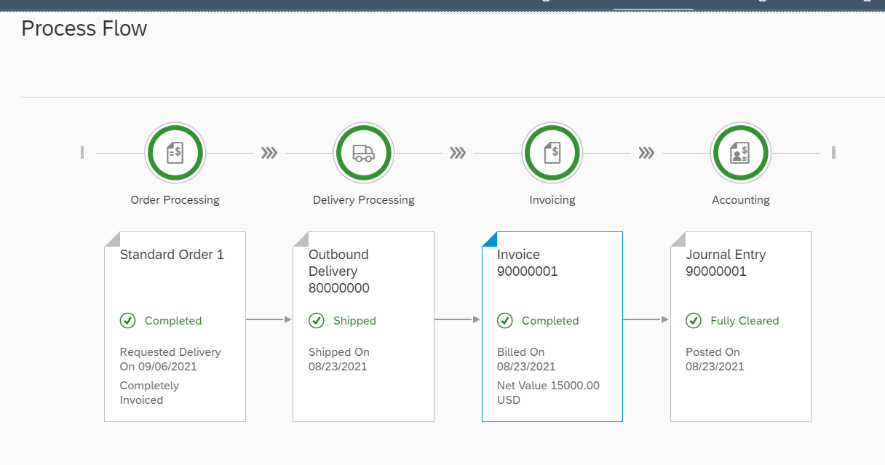
Pic 14. Process Flow

